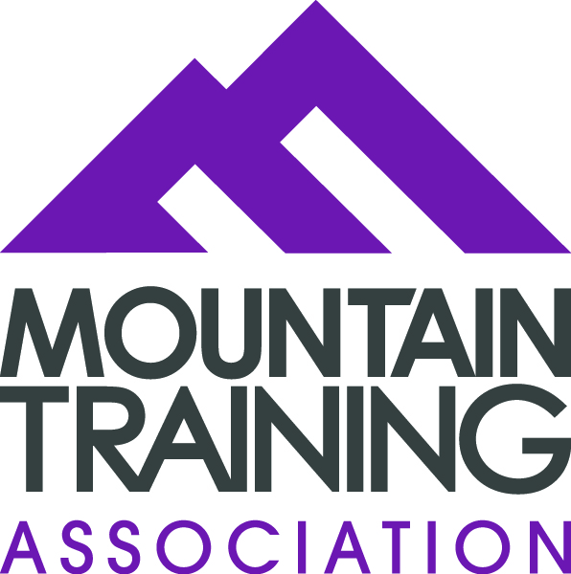
Please complete and return your application to mentoring@mountain-training.org by Friday 14th April 2023.

MTA Mentee Application Form

Please read the programme details below. Then complete the application on page 2 and email it to mentoring@mountain-training.org
Note: the information you provide is confidential and will be used only to determine eligibility for the mentoring program and for the purpose of finding a suitable mentor.

Programme Requirements

Your commitment to MTA’s mentoring programme will be for a 12-month period, starting when you are formally connected with your mentor. Subject to agreement between you and your mentor, your mentoring relationship may continue beyond the 12-month period, until you pass your assessment, or until you decide, by mutual agreement, to end the formal relationship.

During this 12-month period you will be expected to:
- Agree a mentoring contract with your mentor. The contract will set out how you will conduct your relationship and include discussion about your expectations of one another.
- Set the goals you want to work towards and agree with your mentor how you will work towards those goals.
- Conduct a minimum of 6 interactions with your mentor.
- If geographical location allows have a face-to-face meeting
- Submit feedback to MTA for monitoring and evaluation purposes at 6 months and at the end of the 12 months period. Or after completing your assessment, if this is within the 12 month period.

What Happens Next?

Matching
We will match mentoring pairs based on qualification and if possible, location. We will consider what mentees need and what mentors can give. If you have any specific preferences in terms of the person you would like to have as a mentor, please describe them here. We cannot guarantee to find your ideal person, but it would be good to know your preferences.

We will be hosting an online evening session via zoom, which will include a Mentee tutor led session, followed by a meet your mentor session on 23rd May 6.30pm to 8.30pm, please make every effort to make yourself available to attend. Thank you.

Full Name: | Preferred Title Mr/Mrs/Miss/Ms
MTA membership no/candidate ID | Tel. No.
Address:

E-Mail:
Mountain Training qualification registrations (you must be registered on one leadership award to be eligible):

Mountain Training qualification training attended (you must have attended one leadership award training to be eligible):

Mountain Training qualifications held (if any):

Occupation – briefly describe your current or most recent role

What is your motivation for applying to be a mentee? What do you hope to gain from the process?

To help your mentor understand what you would like to get out of the mentoring programme, please indicate the areas on which you feel you would benefit the most from help and advice:
 | Y/N | Please describe any other issues you would like help with that aren’t listed.
Setting my intentions i.e. knowing what I need to do to attend an assessment
Improving my teaching/coaching skills

Improving my group management skills

Identifying personal motivation factors i.e. what do I need to get me to an assessment.

Confidence building

Choosing appropriate CPD that is relevant to my goals
Planning ongoing personal development. Further training/ qualifications.

Hello, this is me
Mentors have said that they would appreciate knowing a little bit about their mentee prior to meeting for the first time. In 50 words or less, please introduce yourself to your mentor.
(We will include your intro in an email to your mentor if we are able to match you.)

Hi, my name is……..

I confirm that I am able to meet the commitments described above.

I agree to support the mission, aims and core principles of the Mountain Training Association and declare that the above information is correct.

Full Name: …………………………………………………………………………………………………

Signature: …………………………………………………… Date: …………………………………..

