Camping Leader Assessment course notes

Introduction

The Camping Leader qualification is for people who wish to supervise a camping group and develop participants’ camping proficiency by teaching campcraft activities.

A qualified Camping Leader can operate in a variety of campsites, all with vehicle access, including land with no facilities and commercial campsites offering a range of facilities. A qualified Camping Leader who also holds a Mountain Training walking leadership qualification can operate in terrain within the scope of that scheme i.e. journey and wild camp.

The Camping Leader scheme is ideal for those involved with the Duke of Edinburgh's Award, President’s Award and/or Ten Tors training among other things. The skills covered apply to groups using commercial campsites as well as wild camping. This is an eight hour course.
Mountain Training aims to inspire, enable and develop people in walking, climbing and mountaineering through the provision of nationally and internationally recognised skills training and leadership qualifications. All Mountain Training courses are quality assured.

Mountain Training: Our Ethos

Prerequisites for the Camping Leader assessment course
There is no formal face to face training component in this scheme. Instead, Mountain Training has developed an optional online training resource to help candidates familiarise themselves with the Camping Leader syllabus and associated competencies prior to attending assessment. A link to access the training (hosted on teachable.com) will be sent when you register on the scheme.

Before you book onto a Camping Leader assessment course you should;

- Be at least 18 years old
- Have personally undertaken and logged an absolute minimum of five overnight camps, ideally in a variety of contexts.
- Have assisted with or overseen at least two group camps. If personal camping has only been undertaken when also supervising a group, then these two group camps can be part of the total submitted for personal camping i.e. some candidates may need to log only five overnight camps in total. Reflective comments must accompany the group supervision evidence.
- Be familiar with the syllabus.
- Be an experienced self-sufficient camper.
- Have experience of the supervision of camping groups.
- Have physically attended and completed (i.e. not online) a first aid course which involved at least one full day or eight hours of instruction and included an element of assessment

Please ensure you have entered your minimum prerequisites in your digital logbook (DLOG) at the time of confirming your place on the course.

Camping Leader course content

The course follows the Camping Leader syllabus. The Camping Leader assessment takes place over the course of a day or a number of sessions building up to a minimum eight hours contact time and will assess the following areas:

- Leadership and group management
- Planning and supervision
- Teaching and learning skills
- Camping Equipment
- Camping food and cookery

Detailed information on each of the above topics can be found in the Camping Leader handbook.

Potential outcomes of assessment
Following the assessment the course director will complete a course report on CMS which will record one of three possible results:

Pass: Awarded where the candidate has demonstrated appropriate knowledge and application of the course syllabus, and has shown the necessary experience and attributes of a Hill and Moorland Leader.
Defer: Awarded where the candidate has generally performed well and has shown the necessary experience and attributes, but where complete proficiency has not been attained in certain aspects of the syllabus or where a lack of experience has been identified.
Fail: Awarded where the candidate’s performance has been generally weak, or the necessary experience and attributes have not been shown. A complete assessment course will need to be subsequently attended.

When a candidate's performance merits a defer or fail result the candidate will have a formal written report containing individual feedback. All relevant information will be included to support the deferred/failed candidate and the assessor who conducts the re-assessment.

Open access to courses
Mountain Training is committed to ensuring that everyone has equal opportunity to attend our courses. If you have a particular need that requires extra assistance, please discuss it with Mountain Training or your provider.
More information can be found here

Sustainable Transport
Mountain Training recognises that climbing, hill walking and mountaineering impact on the environment, and acknowledges the responsibility to take reasonable measures to safeguard the environment for both the present and future generations. We therefore ask participants to consider sustainable transport to access courses.
The BMC Community Liftshare site

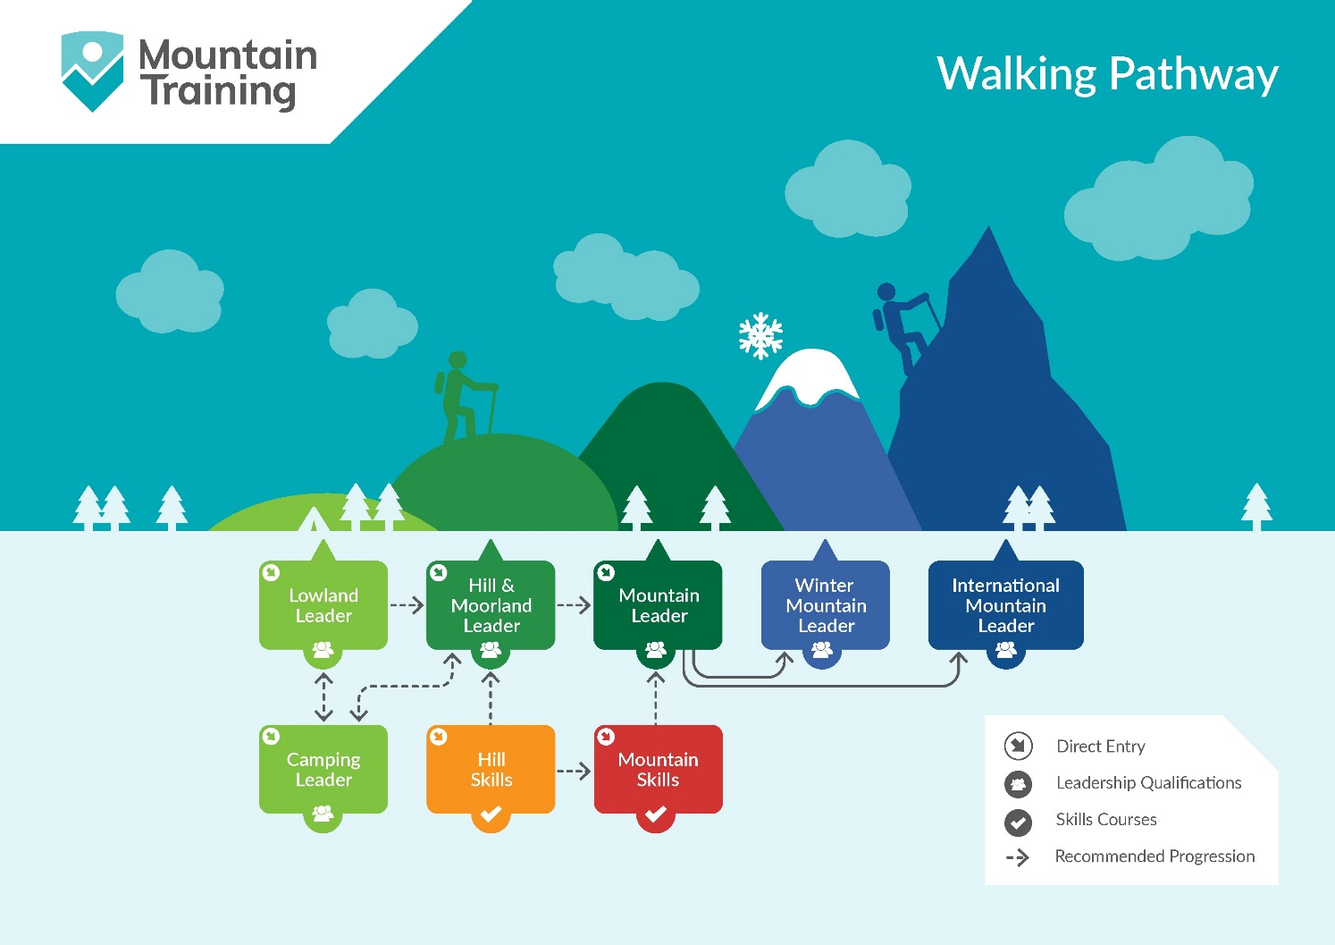

Insurance
Mountain Training recommends that you consider personal accident and cancellation insurance. If you already have insurance cover, check that it covers you for the activity you are undertaking.

Partnerships
Mountain Training Association - The Mountain Training Association is a membership community that provide members with support and development opportunities, mentoring, resources, workshops and events to help those working towards their qualification, and keep skills and knowledge current for those already qualified.

British Mountaineering Council - The British Mountaineering Council (BMC) is the national representative body for England and Wales that exists to protect the freedoms and promote the interests of climbers, hill walkers and mountaineers.

