Climbing Wall Development Instructor assessment course notes

Introduction
The Climbing Wall Development Instructor scheme is for experienced instructors wishing to teach advanced indoor climbing techniques, including lead climbing on indoor or outdoor artificial climbing walls and structures with fixed protection.

The Climbing Wall Development Instructor assessment course aims to assess the technical skills, judgements and areas of knowledge deemed necessary to ensure an individual is safe to do so.
This is a one day course (6 hours).

Mountain Training aims to inspire, enable and develop people in walking, climbing and mountaineering through the provision of nationally and internationally recognised skills training and leadership qualifications. All Mountain Training courses are quality assured.

Mountain Training: Our Ethos

Prerequisites for the Climbing Wall Development Instructor assessment course
Before you book onto a Climbing Wall Development Instructor assessment course;

- You must have attended a Climbing Wall Development Instructor (or Climbing Wall Leading Award) training course or have been granted exemption from training.
- You must be familiar with the syllabus.
- You must have logged a minimum of 100 different lead climbs, at least half of which must be a grade of French 6a or above at 3 different major climbing walls.
- You must have assisted or observed at least 5 teaching leading sessions delivered by a suitably qualified person. These 5 sessions must have Personal Reflective Comments recorded on DLOG.
- You must hold a current first aid qualification, relevant to your work as a Climbing Wall Development Instructor.

Please ensure you have entered your minimum prerequisites in your digital logbook (DLOG) at the time of confirming your place on the assessment course.
Climbing Wall Development Instructor course content
The course follows the Climbing Wall Development Instructor syllabus. A typical assessment course will cover the following areas:

Technical competence
- Equipment
- Belaying
- Personal skills

Management and Decision Making
- Planning and structure of sessions
- Management of participants
- Decision Making
- Knowledge and demonstration of techniques

Teaching and Learning Skills

The climbing wall environment
- Access
- Etiquette and ethics

Detailed information on each of the above topics can be found in the Climbing Wall Development Instructor handbook and the onus is on you to be competent in all of them by the time you come to assessment.

Potential outcomes of assessment
Following the assessment the course director will complete a course report on CMS which will record one of three possible results:

Pass: Awarded where the candidate has demonstrated appropriate knowledge and application of the course syllabus, and has shown the necessary experience and attributes of a Climbing Wall Development Instructor.
Defer: Awarded where the candidate has generally performed well and has shown the necessary experience and attributes, but where complete proficiency has not been attained in certain aspects of the syllabus or where a lack of experience has been identified.
Fail: Awarded where the candidate’s performance has been generally weak, or the necessary experience and attributes have not been shown. A complete assessment course will need to be subsequently attended.

When a candidate's performance merits a defer or fail result the candidate will have a formal written report containing individualised feedback. All relevant information will be included to support the deferred/failed candidate and the assessor who conducts the reassessment.

Open access to courses
Mountain Training is committed to ensuring that everyone has equal opportunity to attend our courses. If you have a particular need that requires extra assistance, please discuss it with Mountain Training or your provider.
More information can be found here

Sustainable Transport
Mountain Training recognises that climbing, hill walking and mountaineering impact on the environment, and acknowledges the responsibility to take reasonable measures to safeguard the environment for both the present and future generations. We therefore ask participants to consider sustainable transport to access courses.
The BMC Community Liftshare site

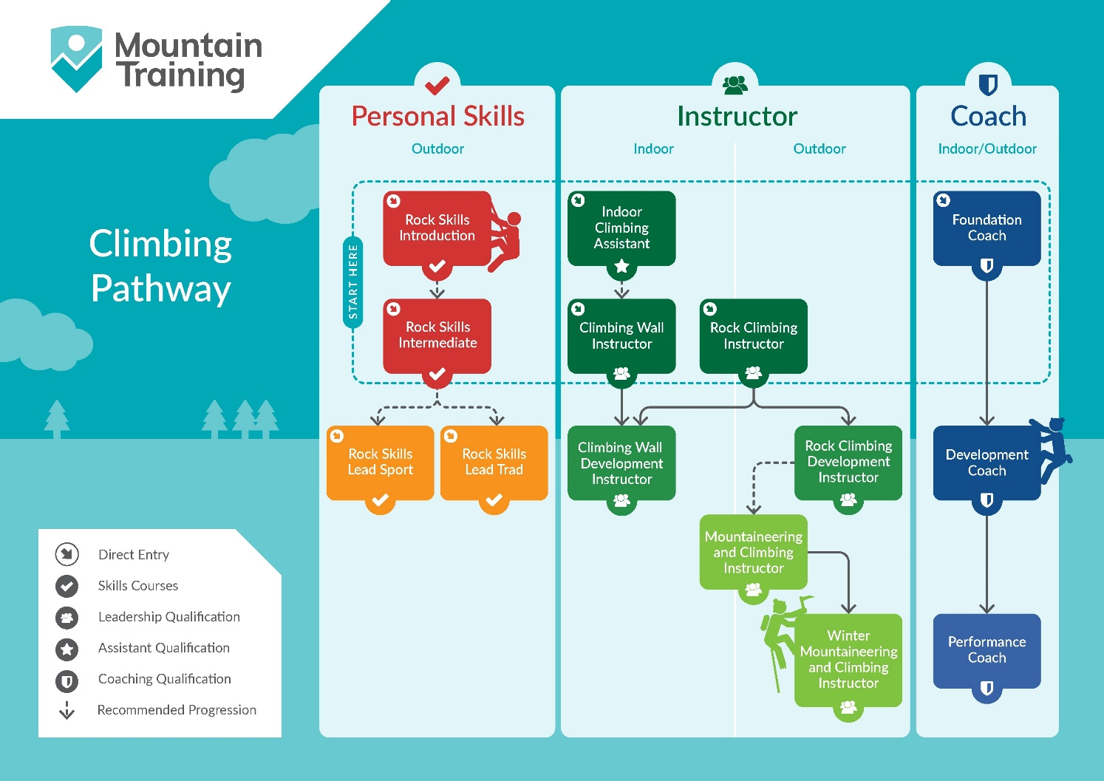
Insurance
Mountain Training recommends that you consider personal accident and cancellation insurance. If you already have insurance cover, check that it covers you for the activity you are undertaking.

Partnerships
Mountain Training Association - The Mountain Training Association is a membership community that provide members with support and development opportunities, mentoring, resources, workshops and events to help those working towards their qualification, and keep skills and knowledge current for those already qualified.

British Mountaineering Council - The British Mountaineering Council (BMC) is the national representative body for England and Wales that exists to protect the freedoms and promote the interests of climbers, hill walkers and mountaineers.

