Hill and Moorland Leader training course notes

Introduction
The Hill and Moorland Leader scheme is designed to train and assess those who wish to lead hill walking groups on day walks in the defined terrain in summer conditions. The Hill and Moorland Leader has been developed from, and succeeds, the Walking Group Leader. The Hill and Moorland Leader training course aims to develop the technical skills, judgements and areas of knowledge deemed necessary to ensure an individual is safe to do so. This is a 3 day course (minimum of 30 hours).

Mountain Training aims to inspire, enable and develop people in walking, climbing and mountaineering through the provision of nationally and internationally recognised skills training and leadership qualifications. All Mountain Training courses are quality assured.

Mountain Training: Our Ethos
Learn, Lead, Inspire - Into the Hills

Prerequisites for the Hill and Moorland Leader training course
Before you book onto the Hill and Moorland Leader training course;
- You must be registered on the scheme
- You must have recorded a minimum of 20 Quality Hillwalking Days on appropriate terrain which can have taken place at any point (pre or post registration).

Please ensure you have entered your minimum prerequisites in your digital logbook (DLOG) at the time of confirming your place on the course.

Hill and Moorland Leader training course content
The course follows the Hill and Moorland Leader syllabus. A typical course will cover the following areas:

- Walking and group management
- Navigation
- Hazards and emergency procedures
- Equipment
- Responsibilities of the leader
- Group management
- Access, conservation, and environmental knowledge
- Weather
- Background Knowledge

Detailed information on each of the above topics can be found in the Hill and Moorland Handbook, and the onus is on you to be competent in all of them by the time you come to assessment.

Potential outcomes
Following training a course report will be created. The results you can achieve are:

Completed: You have attended and completed the training course and met the prerequisite requirements.

Not yet completed: If for any reason you do not complete the required hours for a course you will receive this result. In all cases an action plan will be discussed and created for you. Providers have up to 21 days to submit a course report, which allows for you to submit further information if necessary, for example if you have not fully met the prerequisite requirements.

Candidates are reminded that attendance on a training course must not in any way be considered a qualification in its own right. This is only achieved by passing the Hill and Moorland Leader assessment.

Access to courses
Mountain Training is committed to ensuring that everyone has equal opportunity to attend our courses. If you have a particular need that requires extra assistance, please discuss it with Mountain Training or your provider.
More information can be found here

Sustainable Transport
Mountain Training recognises that climbing, hill walking and mountaineering impact on the environment, and acknowledges the responsibility to take reasonable measures to safeguard the environment for both the present and future generations. We therefore ask participants to consider sustainable transport to access courses.
The BMC Community Liftshare site

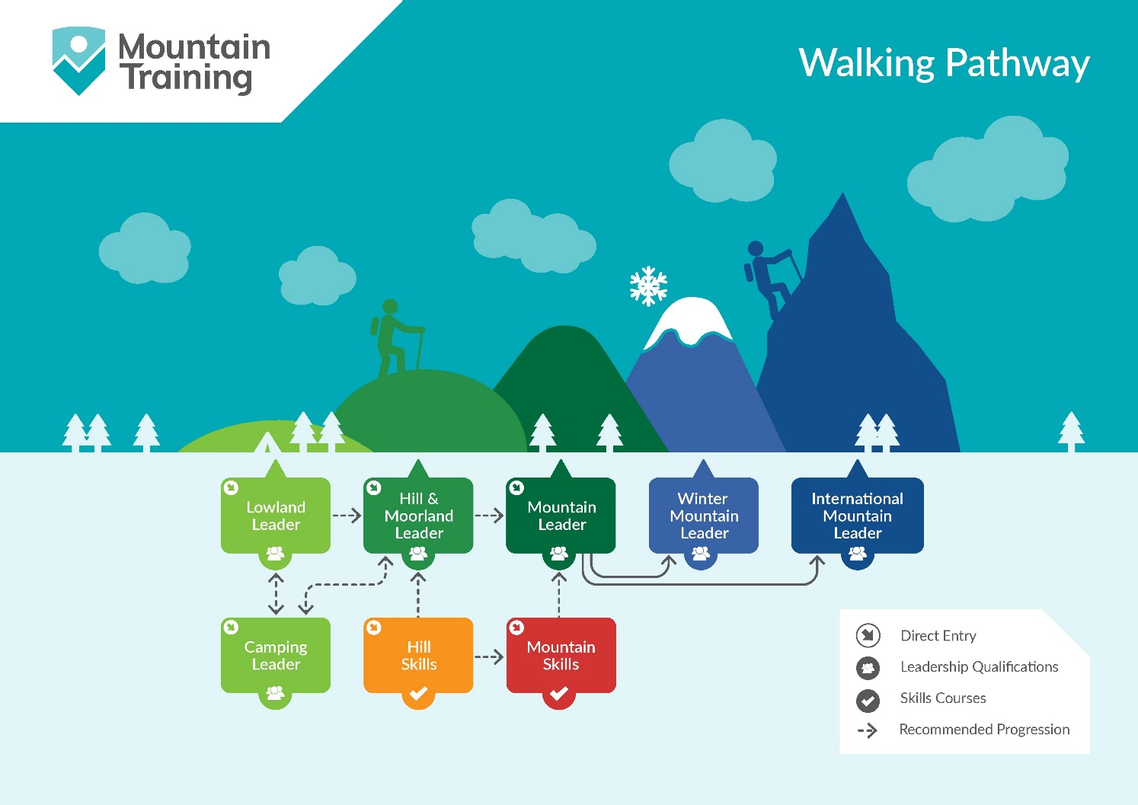

Insurance
Mountain Training recommends that you consider personal accident and cancellation insurance. If you already have insurance cover, check that it covers you for the activity you are undertaking.

Partnerships
Mountain Training Association - The Mountain Training Association is a membership community that provide members with support and development opportunities, mentoring, resources, workshops and events to help those working towards their qualification, and keep skills and knowledge current for those already qualified.

British Mountaineering Council - The British Mountaineering Council (BMC) is the national representative body for England and Wales that exists to protect the freedoms and promote the interests of climbers, hill walkers and mountaineers.

