Mountain Leader assessment course notes

Introduction
The Mountain Leader scheme was established to promote the safe enjoyment of the hills and mountains. The scheme provides training and assessment in the technical and group management skills required by those who wish to lead groups in the mountains, hills and moorlands of the United Kingdom and Ireland, other than in winter conditions. The Mountain Leader scheme offers the opportunity to gain technical competence in leading walkers in the hills and mountains.

The Mountain Leader assessment course allows you to demonstrate the technical skills, judgements and areas of knowledge deemed necessary to ensure an individual is safe to work within the scope of the award. It does not provide a rock climbing qualification, nor does it cover the skills required for the planned use of a rope. This is a 5 day course (minimum of 60 hours).

Mountain Training aims to inspire, enable and develop people in walking, climbing and mountaineering through the provision of nationally and internationally recognised skills training and leadership qualifications. All Mountain Training courses are quality assured.

Mountain Training: Our Ethos
Learn, Lead, Inspire - Into the Hills

Prerequisites for the Mountain Leader assessment course
Before you book onto the Mountain Leader assessment course you must;
- Have attended a Mountain Leader training course (or have been granted exemption) and be familiar with the syllabus
- Have logged a minimum of 40 Quality Mountain Days in three different regions of the UK and Ireland
- Hold a current first aid certificate, minimum 16 hours and relevant to your work as a Mountain Leader
- Have logged at least 8 nights camping, including at least 4 nights wild camping

Please ensure you have entered your minimum prerequisites in your digital logbook (DLOG) at the time of confirming your place on the assessment course.

Mountain Leader assessment course content
The course will cover the Mountain Leader syllabus which includes the following areas:

- Group management and the responsibilities of the group leader
- Navigation
- Access and the environment
- Hazards (including steep ground and rivers) and emergency procedures
- Equipment
- Expedition skills
- Weather
- Background knowledge

Detailed information on each of the above topics can be found in the Mountain Leader Handbook, and the onus is on you to be competent in all of them by the time you come to assessment.

Potential outcomes of assessment
Following the assessment the course director will complete a course report on CMS which will record one of three possible results:

Pass: Awarded where the candidate has demonstrated appropriate knowledge and application of the course syllabus, and has shown the necessary experience and attributes of a Mountain Leader.
Defer: Awarded where the candidate has generally performed well and has shown the necessary experience and attributes, but where complete proficiency has not been attained in certain aspects of the syllabus or where a lack of experience has been identified.
Fail: Awarded where the candidate’s performance has been generally weak, or the necessary experience and attributes have not been shown. A complete assessment course will need to be subsequently attended.

When a candidate's performance merits a defer or fail result the candidate will have a formal written report containing individualized feedback. All relevant information will be included to support the deferred/failed candidate and the assessor who conducts the re-assessment.

Access to courses
Mountain Training is committed to ensuring that everyone has equal opportunity to attend our courses. If you have a particular need that requires extra assistance, please discuss it with Mountain Training or your provider.
More information can be found here

Sustainable Transport
Mountain Training recognises that climbing, hill walking and mountaineering impact on the environment, and acknowledges the responsibility to take reasonable measures to safeguard the environment for both the present and future generations. We therefore ask participants to consider sustainable transport to access courses.
The BMC Community Liftshare site

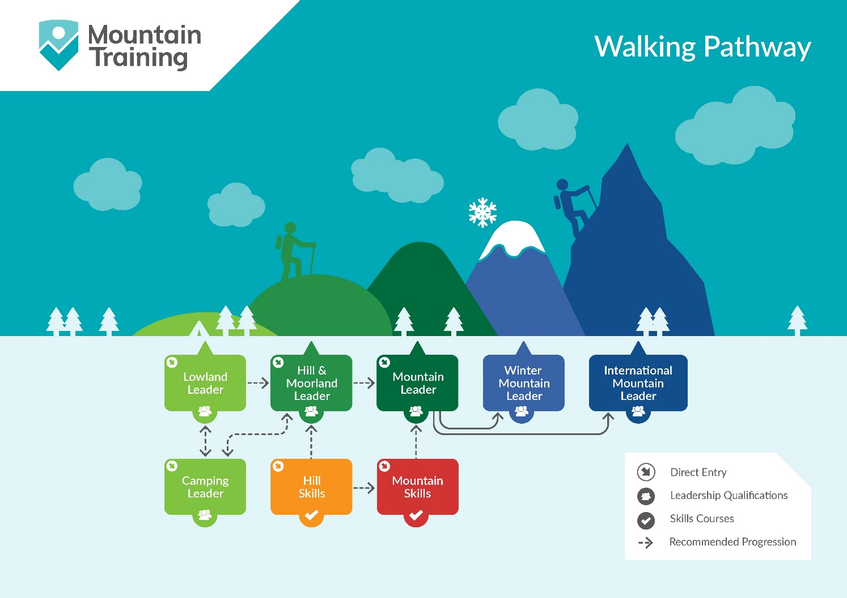

Insurance
Mountain Training recommends that you consider personal accident and cancellation insurance. If you already have insurance cover, check that it covers you for the activity you are undertaking.

Partnerships
Mountain Training Association - The Mountain Training Association is a membership community that provide members with support and development opportunities, mentoring, resources, workshops and events to help those working towards their qualification, and keep skills and knowledge current for those already qualified.

British Mountaineering Council - The British Mountaineering Council (BMC) is the national representative body for England and Wales that exists to protect the freedoms and promote the interests of climbers, hill walkers and mountaineers.

