Supporting a candidate with action planning

As part of training or assessment course debriefs you can support candidates to develop their own personal action plans. Action planning is more successful if supported by a mentor or course staff.

1. The candidate’s overall goal should be initially established in discussion e.g. ‘*I want to get good at navigation’*.
2. Candidates should be encouraged to reflect and, from further discussion, create a SMART goal:

* 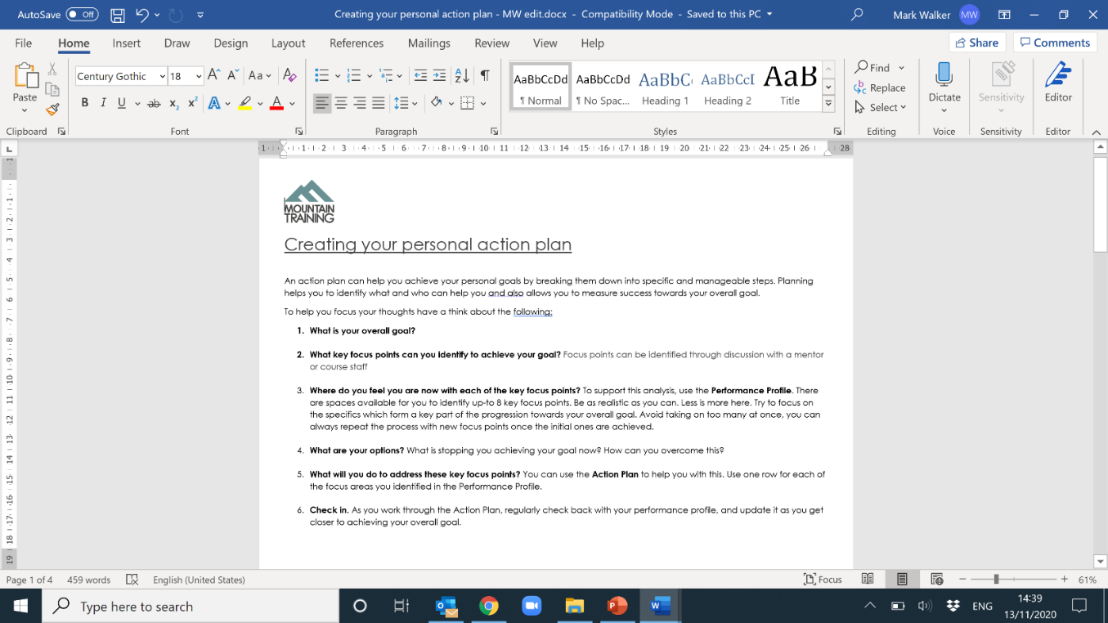Specific
* Measurable
* Attainable/Appropriate
* Relevant/Realistic
* Time limited

e.g. *I want to develop my micro navigation so I can accurately find small contour features. I want to pass my ML by the end of the year.*

1. Use these goals to support the candidate to fill in their **Personal Action Plan** and encourage them to regularly check back in on their progress using this resource.

If you would like to know more about the processes of coaching and goal setting, particularly the GROW model used to develop coaching behaviors, there are webinar sessions and related resources available here: <https://www.mountain-training.org/england/course-staff-coaching-behaviours> (Dr Samantha McElligott)

Example questions to prompt discussion to develop SMART goals.

**1.Goal:**

* How do you want your outdoor career to progress?
* What outcome do you want from this process?
* How do you feel this process will help you?
* Will this session be sufficient to cover the points you need to cover?

**2. Reality:**

* How do you see your style of management/leadership, navigation skills, background understanding etc.?
* How do you think others view your style of management/leadership, navigation skills, background understanding etc.?
* Can you provide examples of this?
* Where do you think your strengths/weaknesses lie?

**3. Options:**

* How could the situation change?
* How could you improve the situation?
* Can you provide some specific options for action?
* Are you aware of the possible downsides to those options?
* Which of these suggested options would you like to try?

**4. Will:**

* How can you put these options into action?
* What will you need for this? Who could support you further?
* Are you aware of any obstacles to these actions?
* What further support do you need from your coach?
* Does your employer offer in-house support for change?
* Can you put this action plan into writing?