Rock Climbing Instructor assessment course notes

Introduction
The Rock Climbing Instructor scheme enables experienced rock climbers to instruct climbing on single pitch crags and artificial climbing walls and towers.

Within the defined terrain a qualified Rock Climbing Instructor can:
- Teach climbing skills.
- Take people climbing, bouldering and abseiling.
- Manage groups safely in these activities.

The assessment course is an opportunity for you to demonstrate your competence in all areas of the syllabus. This is a two-day course (minimum of 16 hours) with at least 4 hours delivered in a climbing wall.

Mountain Training aims to inspire, enable and develop people in walking, climbing and mountaineering through the provision of nationally and internationally recognised skills training and leadership qualifications. All Mountain Training courses are quality assured.

Mountain Training: Our Ethos

Prerequisites for the Rock Climbing Instructor assessment course
Before you book onto a Rock Climbing Instructor assessment course;
- You must have attended a Rock Climbing Instructor (or Single Pitch Award) training course or been granted exemption from training.
- You must be familiar with the syllabus.
- You must be competent leading Severe grade climbs on outdoor crags with leader-placed protection.
- You must have led a minimum of 40 graded rock climbs with traditional protection at a variety of venues (of which at least 20 MUST be at Severe grade or above).
- You must be proficient in the use of climbing walls and have a minimum of 30 climbing wall leads graded at F4 or above.
- You must be proficient in outdoor bolt protected sport climbing and have a minimum of 10 sport climb leads graded at F4 or above.
- You must have assisted in the supervision of 20 instructed sessions. These sessions should be at a variety of different venues with 10 being on indoor climbing walls and the other 10 on outdoor crags. A session is a half day or evening. At least five of these sessions must have Personal Reflective Comments recorded on DLOG.
- You must hold a current first aid qualification, which involved at least two days of training and included an element of assessment.

Please ensure that you have entered the minimum prerequisites in your digital logbook (DLOG) at the time of confirming your place on the assessment course.

Rock Climbing Instructor course content
The course will cover the Rock Climbing Instructor syllabus which includes the following areas:

Technical competence
- Equipment
- Anchors
- Belaying
- Personal skills
- Abseiling
- Background knowledge

Management and Decision Making
- Planning and structure of sessions
- Organising sessions
- Management of participants
- Decision Making
- Personal safety
- Knowledge and demonstration of techniques
- Managing/supervising other staff

Teaching and Learning Skills

The climbing environment
- Access
- Conservation
- Etiquette and ethics

Detailed information on each of the above topics can be found in the Rock Climbing Instructor Handbook and the onus is on you to be competent in all of them by the time you come to assessment.

Potential outcomes of assessment
Following the assessment the course director will complete a course report on CMS which will record one of three possible results:

Pass: Awarded where the candidate has demonstrated appropriate knowledge and application of the course syllabus, and has shown the necessary experience and attributes of a Rock Climbing Instructor.
Defer: Awarded where the candidate has generally performed well and has shown the necessary experience and attributes, but where complete proficiency has not been attained in certain aspects of the syllabus or where a lack of experience has been identified.
Fail: Awarded where the candidate’s performance has been generally weak, or the necessary experience and attributes have not been shown. A complete assessment course will need to be subsequently attended.

When a candidate's performance merits a defer or fail result the candidate will have a formal written report containing individualised feedback. All relevant information will be included to support the deferred/failed candidate and the assessor who conducts the reassessment.

Open access to courses
Mountain Training is committed to ensuring that everyone has equal opportunity to attend our courses. If you have a particular need that requires extra assistance, please discuss it with Mountain Training or your provider.
More information can be found here

Sustainable Transport
Mountain Training recognises that climbing, hill walking and mountaineering impact on the environment, and acknowledges the responsibility to take reasonable measures to safeguard the environment for both the present and future generations. We therefore ask participants to consider sustainable transport to access courses.
The BMC Community Liftshare site

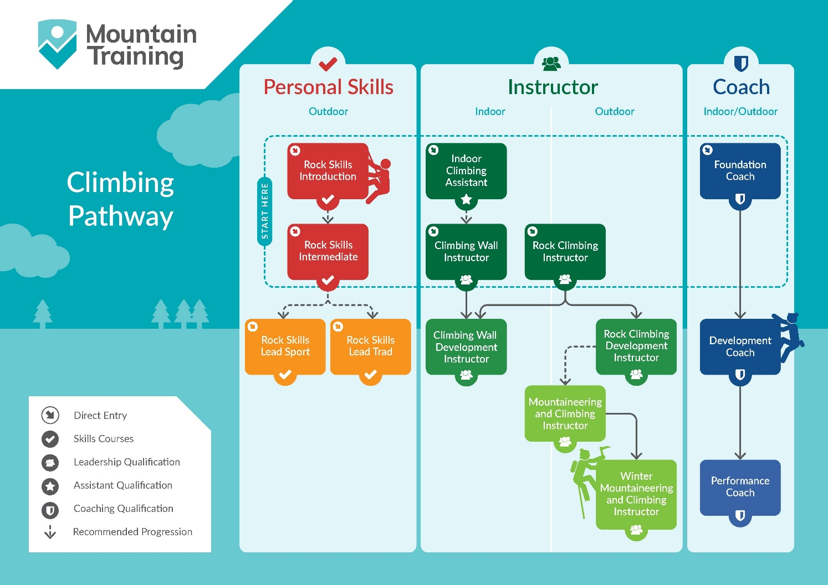
Insurance
Mountain Training recommends that you consider personal accident and cancellation insurance. If you already have insurance cover, check that it covers you for the activity you are undertaking.

Partnerships
Mountain Training Association - The Mountain Training Association is a membership community that provide members with support and development opportunities, mentoring, resources, workshops and events to help those working towards their qualification, and keep skills and knowledge current for those already qualified.

British Mountaineering Council - The British Mountaineering Council (BMC) is the national representative body for England and Wales that exists to protect the freedoms and promote the interests of climbers, hill walkers and mountaineers.

